SECURE VOTING SYSTEM WITH AADHAR VERIFICATION THROUGH BLOCKCHAIN
Design and Implementation
Department of Computer Science and Engineering, TKR College of Engineering & Technology
Batch C1 (CSE-C) · Academic year [ACADEMIC YEAR]
Table 1: Project team
S.No. | Student name | Roll number
1 | Mohammed Anwar-Ul-Haq | 23K91A05F6
2 | Mohammad Mosin | 23K91A05F4
3 | Manda Akshitha | 23K91A05E4
4 | Kothlapur Ganesh | 24K95A0516

Project guide: B Shruthi
Chapter and section numbers quoted in the text (for example Chapter 8 or Section 6.2) refer to the full project report, 17.Final Document. Figures and tables in this document are numbered from 1.

1. DESIGN
This chapter turns the requirements of Chapter 4 into a design. It gives the architecture, the workflow of an election and of one vote, the data flow diagrams at three levels, the UML diagrams, the database design with the way identity and ballot are kept apart, the module design, the algorithms in flow-chart form and the user-interface design. Every diagram was drawn from the code of 8.ProjectCode (the JSON routes in app/api_v1.py, the services, the ledger and the thirteen SQLAlchemy models), and all twelve diagrams are listed again with longer explanations in the block-diagram document.

1.1 Design Goals and Architecture
Six goals shaped the design. Integrity: once a ballot has been accepted it must not be changeable without the change being detectable. One voter, one vote: the rule must hold even if a single layer of the application is bypassed. Separation of identity and ballot: the record that proves a person voted should not be the record that shows what was chosen. Auditability: an independent party must be able to recompute the state of the ledger. Local operation and simplicity: one launcher, one configuration file, one database file, no external service, so that the system can be demonstrated on any laptop. Role separation: the administrator who runs the election, the voter who takes part and the auditor who checks it are different accounts with different rights.
The architecture has four tiers, shown in the figure below. The presentation tier is a React 18 single-page application served by Vite on port 5401; it holds the public pages and the three role consoles and talks to the backend through an Axios client that forwards /api to port 8401. The application tier is FastAPI: app/api_v1.py provides the JSON routes used by the React app, and app/main.py keeps the original server-rendered Jinja pages, which still work but are no longer the main interface. The service tier contains the identity provider, the voting service, the cryptographic helpers, the audit logger and the ledger module with its three validators. The data tier is a single SQLite database, data/aegisballot.db, with thirteen tables, plus three small key files in data/ (secrets.json, validators.json, system_key.json).
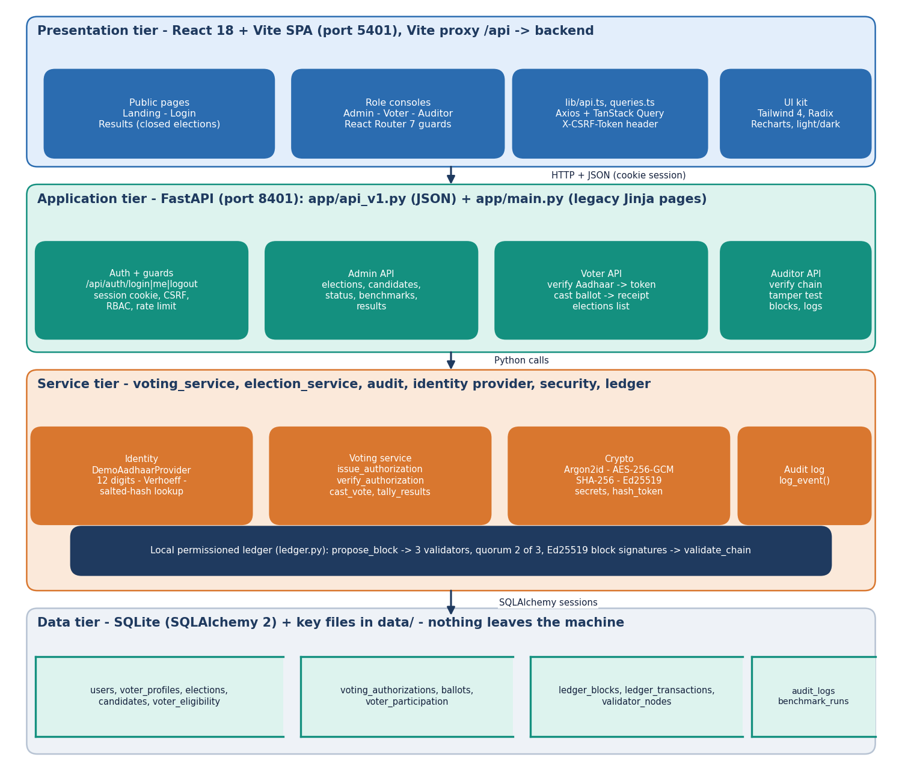
Figure 1: Four-tier architecture of AegisBallot: React single-page app, FastAPI application, service layer with the local ledger, SQLite storage.
The base paper [1] uses a four-tier model as well: MySQL and an Ethereum ledger for storage, Ethereum nodes running smart contracts, a C# web-application tier and client devices. AegisBallot keeps the same separation of concerns but replaces the public-chain tier with a local permissioned ledger, which is the main design departure. The table maps the two designs.
Table 2: Tiers of the base paper's model and of AegisBallot
Tier | Base paper (Oman model) | AegisBallot
Storage | MySQL for credentials and voter data; Ethereum ledger for votes | One SQLite database; the ledger is two tables in the same database
Ledger / consensus | Ethereum nodes execute smart contracts on a Geth test chain | Three in-process validators with Ed25519 keys; a block needs 2 of 3 approvals
Business logic | C# web application | FastAPI services (voting_service, election_service, audit, identity provider)
Client | .NET Core 7 simulators; crypto wallets in the proposal | React 18 browser application with cookie session and CSRF header
Identity | Biometric authentication (simulated) | Aadhaar number checked for format, Verhoeff checksum and registry membership (synthetic registry)

1.2 High-Level Workflow
The life cycle of an election has two parts. In the administration part the administrator creates the election with its title, description and polling window, adds candidates, and sets the status to OPEN. Creating an election also creates a voter_eligibility row for every registered voter. In the voting part each voter passes the identity check, receives a token, casts one ballot and keeps a receipt. When the administrator sets the status to CLOSED the tally is published and the auditor can check the chain.
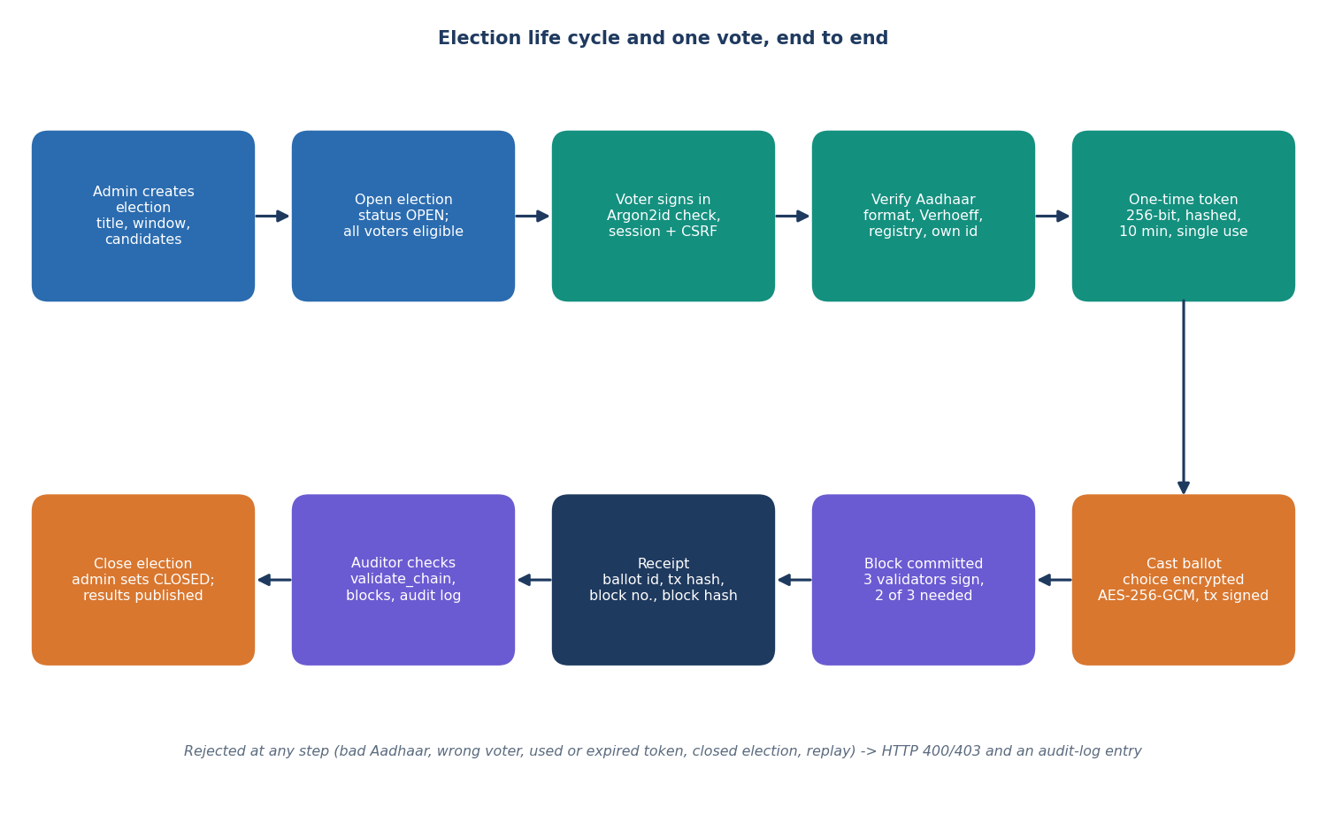
Figure 2: Election life cycle and the path of one vote, from election creation to the auditor's check.
1. Sign in. The voter sends a username and password. The password is verified against an Argon2id hash; a server-side session and a CSRF token are created; an audit entry is written.
2. Verify identity. The voter types the 12-digit Aadhaar number. The provider removes spaces and hyphens, requires twelve digits, checks the Verhoeff checksum and looks up the salted hash. The number must belong to the signed-in account, the voter must be eligible and must not have voted.
3. Receive a token. A 256-bit random token is generated; only its SHA-256 hash is stored, with an expiry of ten minutes; the plain token is returned once to the browser.
4. Cast. The browser sends the candidate id and the token. The service checks the election is OPEN, the candidate is active in that election, the token is valid and unused, and that no participation row exists.
5. Commit. The choice is encrypted with AES-256-GCM, the transaction is hashed and signed, and three validators check and sign the block; two approvals commit it. The ballot row, the used token and the participation row are saved in one commit.
6. Receive a receipt. The voter gets the ballot id, transaction hash, block number and block hash. Any failure returns HTTP 400 or 403, writes an audit entry and stores nothing.
7. Close and audit. After closing, the tally is computed from the ballots table and published; the auditor recomputes the chain with validate_chain, browses blocks and reads the audit log.

1.3 Data Flow Diagrams

1.3.1 Level 0: context diagram
At level 0 AegisBallot is a single process with three human actors and two stores. The voter supplies credentials, an Aadhaar number and a choice and receives a receipt and the published results. The administrator supplies election, candidate and status changes and receives turnout and tallies. The auditor supplies integrity-check requests and receives chain status, blocks and the audit log. The only data sources are the voter registry (a table of hashed synthetic Aadhaar numbers) and the store of ledger, ballots and log entries.
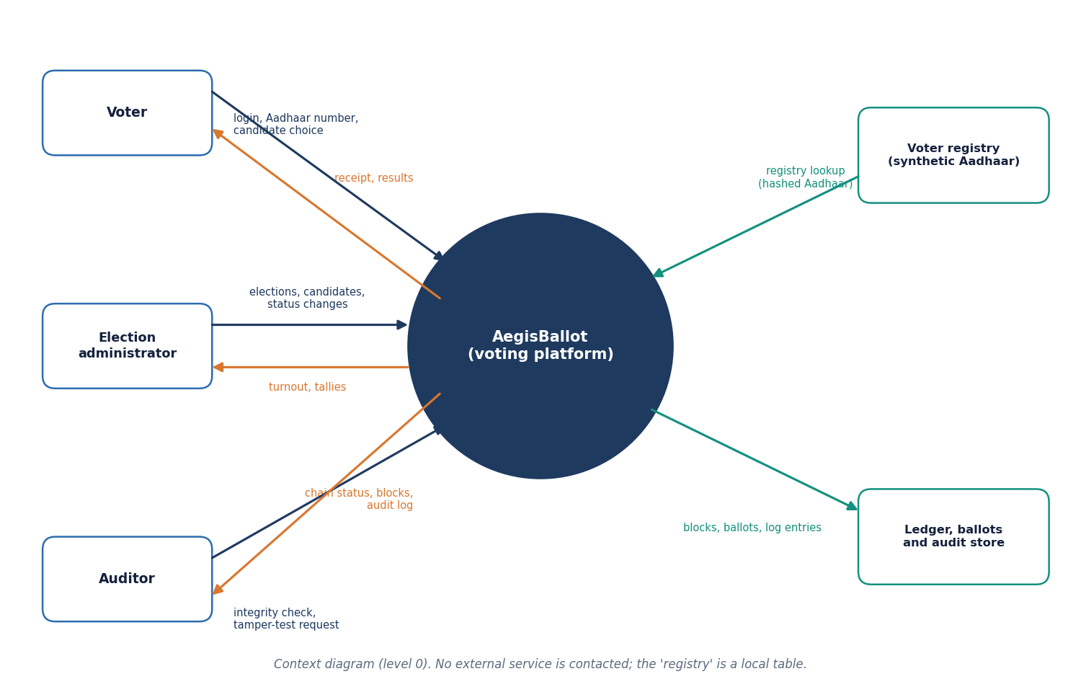
Figure 3: Context diagram (DFD level 0) of AegisBallot with its three user roles and two stores.

1.3.2 Level 1
Level 1 divides the platform into eight processes. The table lists what each process does and which stores it reads and writes.
Table 3: Processes and data stores of the level-1 diagram
Process | Function (code) | Reads | Writes
1.0 Authenticate | POST /api/auth/login: Argon2id verify, session, CSRF token, rate limit | D1 users | session store (memory), D5 audit
2.0 Verify identity | DemoAadhaarProvider.verify: digits, Verhoeff, registry lookup | D1 users and registry | D5 audit
3.0 Issue authorization | issue_authorization: eligibility, not voted, one pending token | D6 elections, D3 | D2 tokens
4.0 Cast and encrypt | cast_vote: checks, AES-GCM, tx hash, signature | D2, D3, D6 | D3 ballots and participation
5.0 Propose and commit block | propose_block: validator checks, quorum, commit | D4 ledger | D4 ledger
6.0 Manage elections | admin routes: create, status, candidates | D6 | D6, eligibility rows
7.0 Audit and verify chain | validate_chain, tamper_test_clone, block browser | D4, D5 | D5 audit
8.0 Tally and publish | tally_results: decrypt and count | D3, D6 | -

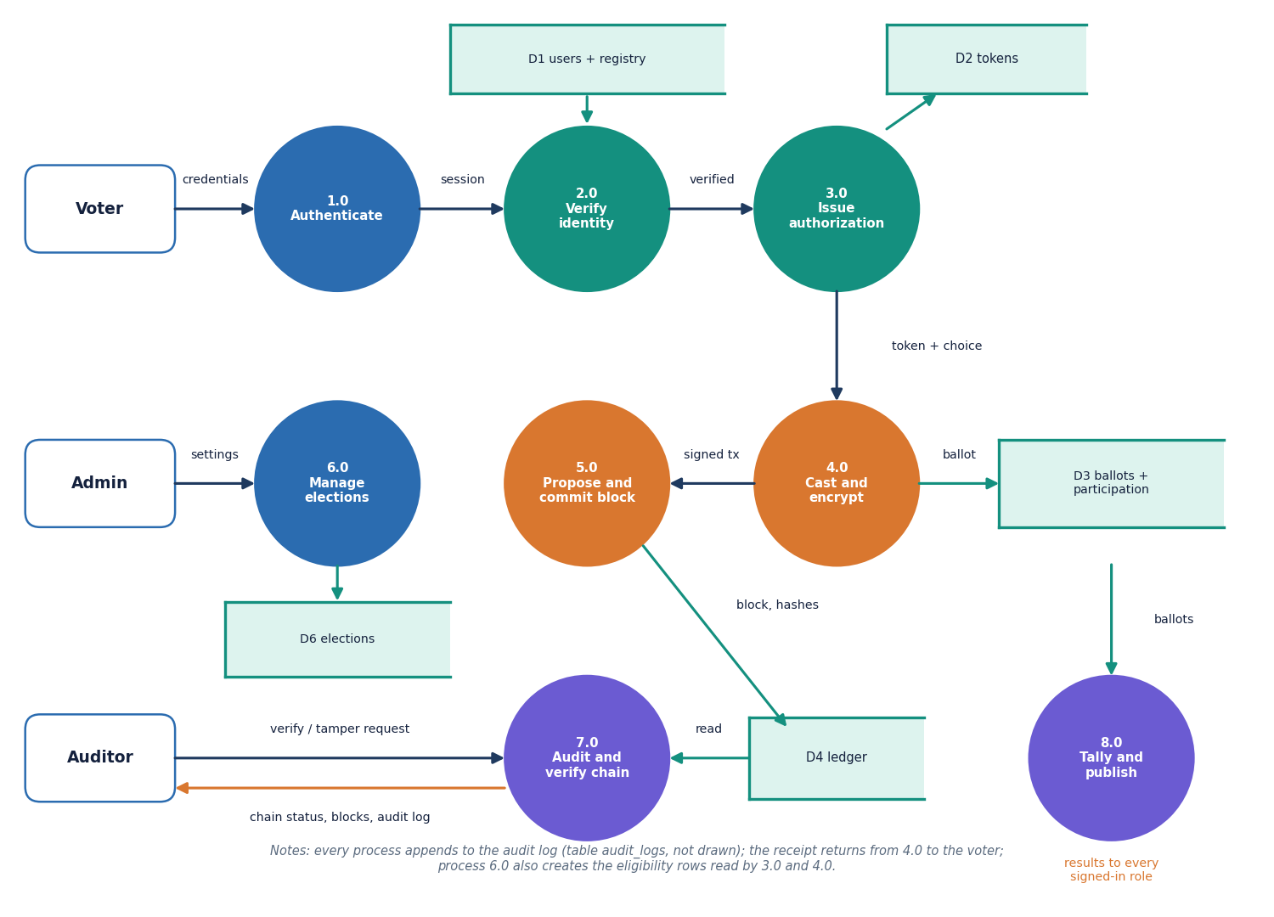
Figure 4: DFD level 1: eight processes and six data stores.

1.3.3 Level 2: casting a ballot
Level 2 expands processes 4.0 and 5.0, the heart of the system. The three guard checks (election and candidate, token, no prior participation) come before any cryptography; the encryption and signing steps produce a transaction; and the ledger steps (schema and uniqueness, validator checks, quorum, commit) decide whether it becomes a block. Only after the block is committed does 4.6 save the ballot, mark the token used and add the participation row, all in one database commit, so that a rejected block leaves no trace.
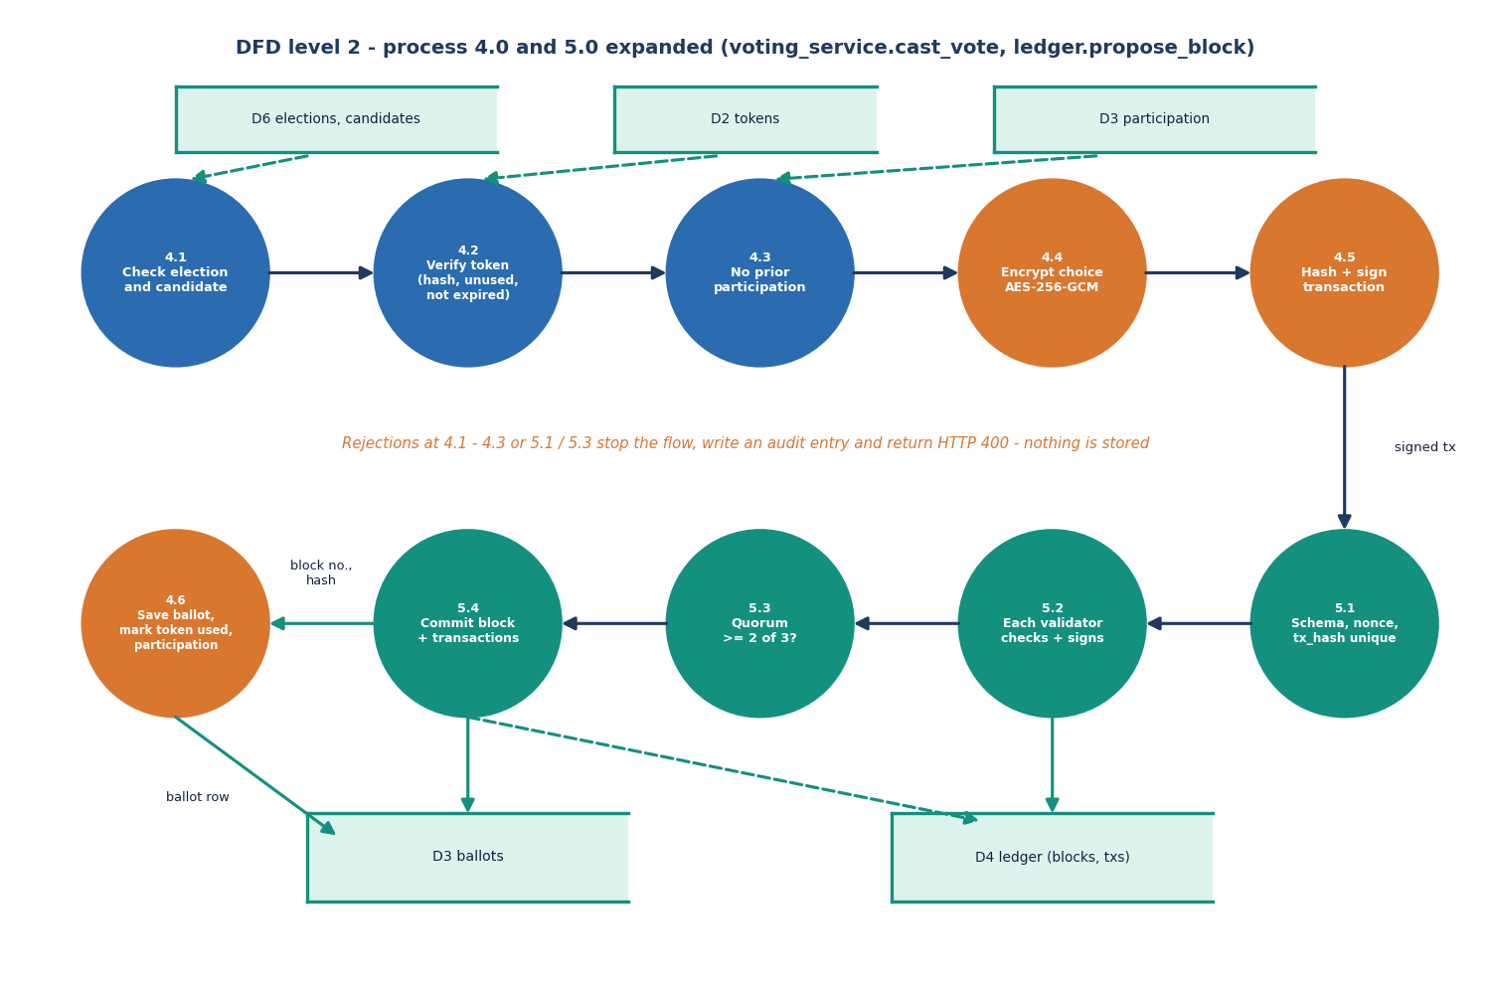
Figure 5: DFD level 2: processes 4.0 and 5.0 expanded into eleven sub-processes (cast_vote and propose_block).

1.4 UML Diagrams

1.4.1 Class diagram
The classes of the diagram are the SQLAlchemy models in app/models/models.py, together with the two service modules and the identity-provider interface. User has at most one VoterProfile. Election owns Candidate rows. VoterEligibility, VotingAuthorization and VoterParticipation are each unique on the pair (election, voter), which is what lets the database refuse a second vote independently of the application code. Ballot has no voter column. LedgerBlock and LedgerTransaction are linked by block index, ValidatorNode stores the three public keys, and AuditLog records actions. IdentityVerificationProvider is an abstract class with one method, verify; DemoAadhaarProvider implements it with the local registry, so a real adapter could be substituted without touching the routes.
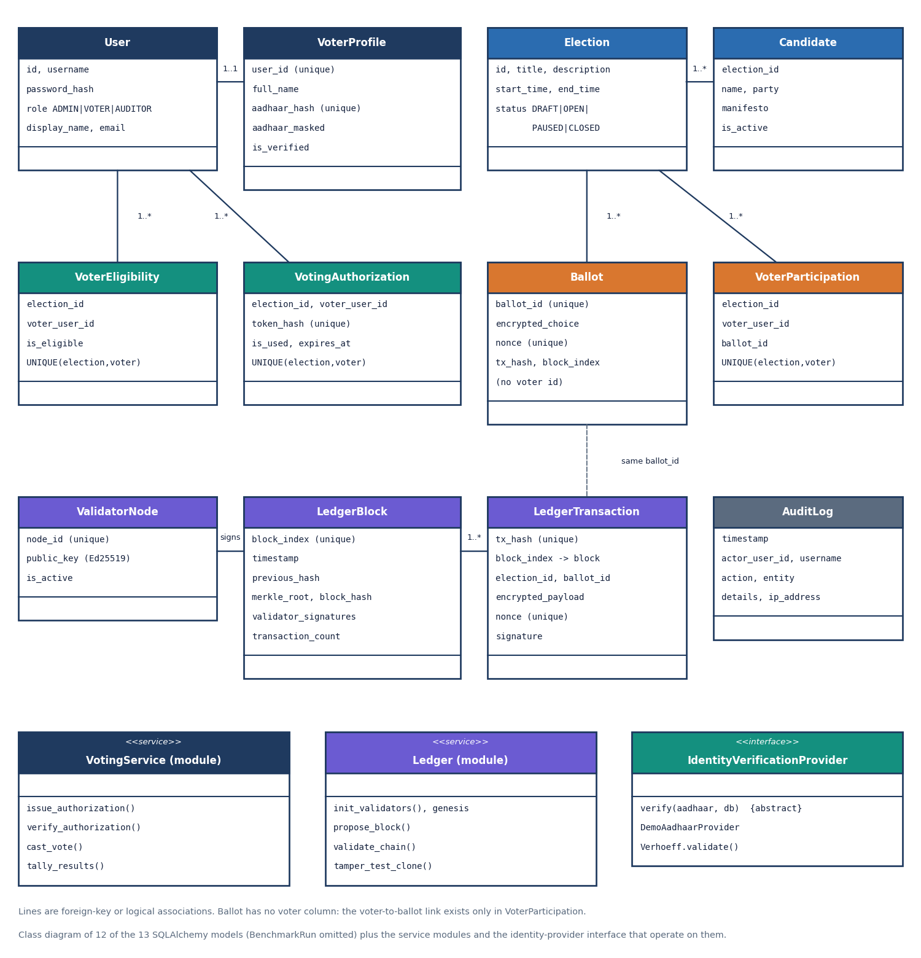
Figure 6: Class diagram of the persistent models with the service modules and the identity-provider interface.

1.4.2 Use-case diagram
There are three actors. The table lists their use cases and the API group that serves each.
Table 4: Use cases by actor
Actor | Use cases | Served by
Voter | Sign in and out; verify Aadhaar identity; cast one encrypted ballot; see receipt and election history; read results of closed elections | /api/auth/*, /api/voter/*, /api/elections/{id}/results
Administrator | Create and configure elections; add and deactivate candidates; open, pause and close elections; read results of any election; read benchmark runs | /api/admin/*, /api/elections/{id}/results
Auditor | Verify chain integrity; browse blocks and their validator signatures; run the tamper demonstration; read the audit log | /api/auditor/*

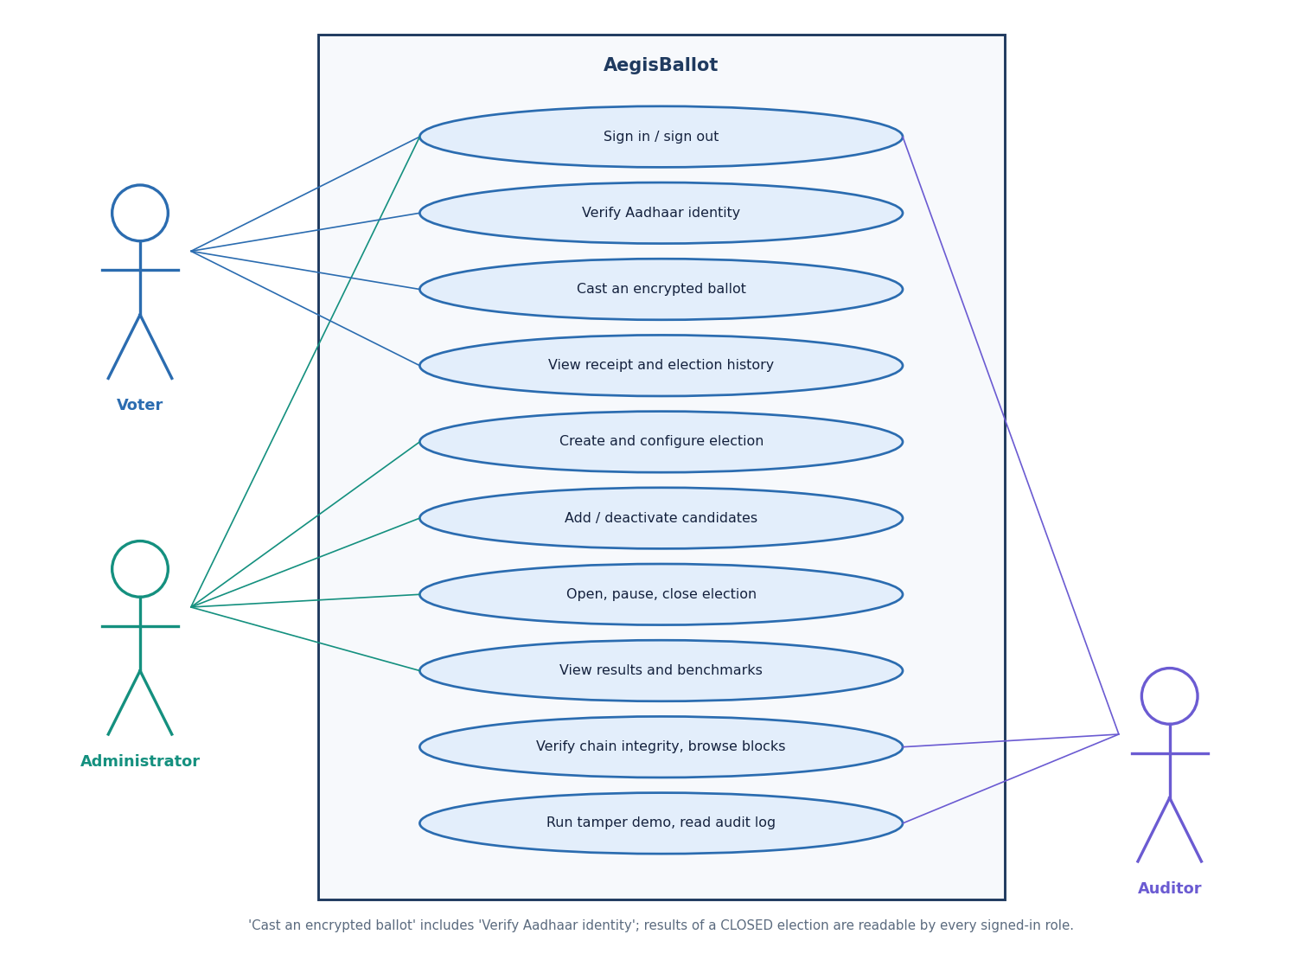
Figure 7: Use cases of the voter, the administrator and the auditor.

1.4.3 Sequence diagram
The sequence diagram follows the two calls that matter, verify and cast. The verify call touches the identity provider and the token store; the cast call goes through the voting service to the ledger and then writes four kinds of rows (block, ballot, token, participation) and the audit entry. The second call returns the receipt. Two details are worth noticing: the token returned by the first call is the only copy of the secret (the database holds only its hash), and the ledger call happens before the ballot row exists, so a failed quorum aborts the whole cast.
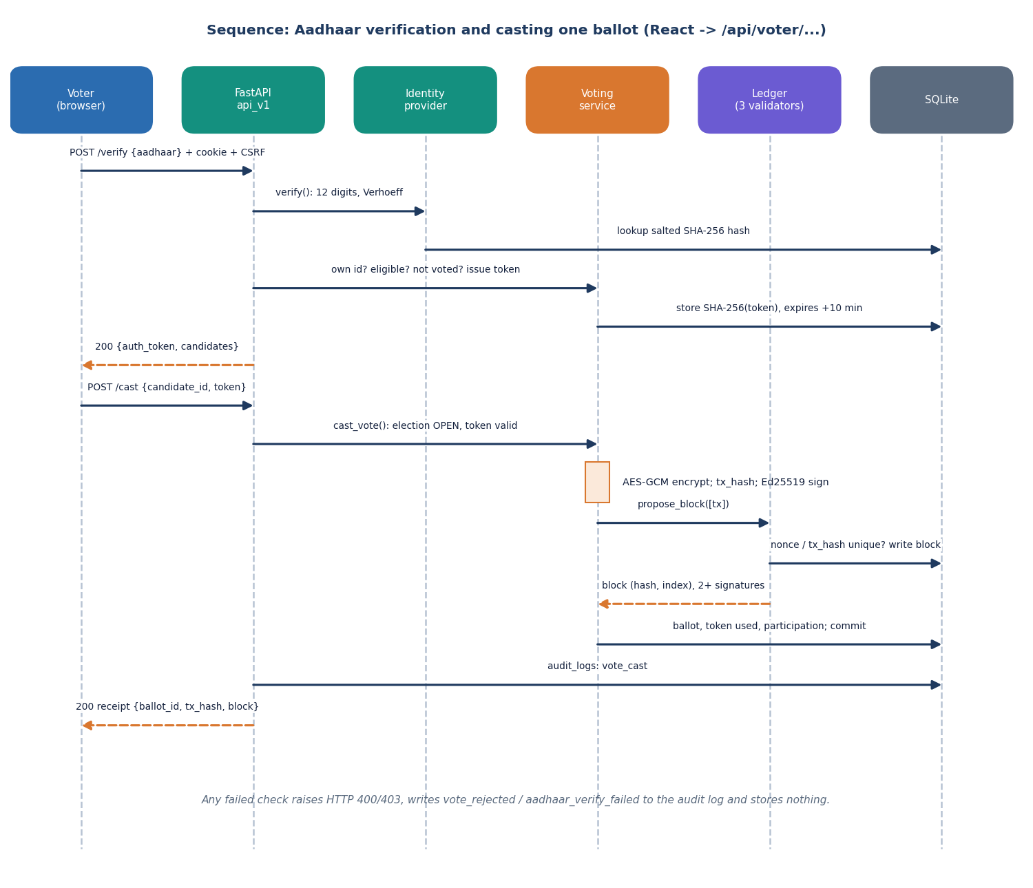
Figure 8: Sequence of Aadhaar verification and casting one ballot through the JSON API.

1.5 Database Design
The database has thirteen tables, created by Base.metadata.create_all at start-up. The entity-relationship diagram shows the tables with their keys; the tables that follow list the columns. Types are those of the SQLAlchemy models; UQ means a unique constraint.
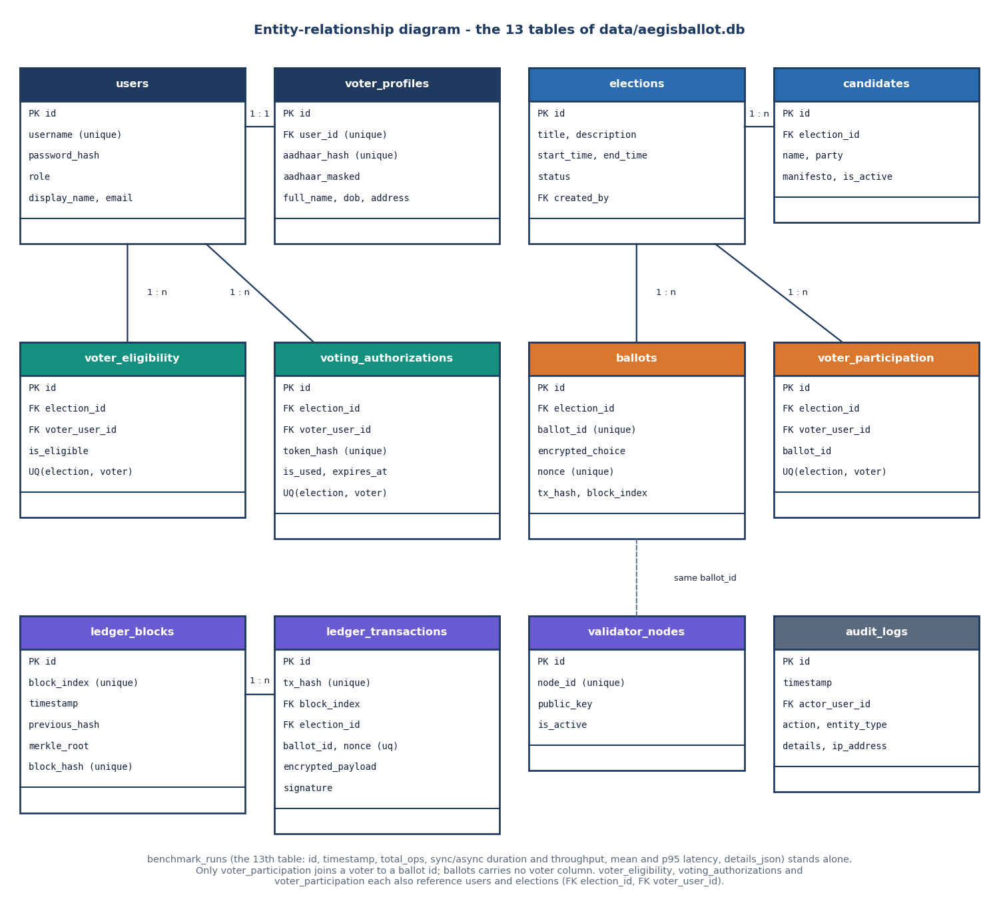
Figure 9: Entity-relationship diagram of the thirteen tables.

1.5.1 People, elections and eligibility
Table 5: Tables for users, elections and eligibility
Table | Columns | Keys and constraints
users | id, username, password_hash (Argon2id), role (ADMIN, VOTER, AUDITOR), display_name, email, created_at | PK id; username unique
voter_profiles | id, user_id, full_name, aadhaar_hash, aadhaar_masked, dob, address, is_verified | PK id; FK user_id (unique, one profile per user); aadhaar_hash unique
elections | id, title, description, start_time, end_time, status (DRAFT, OPEN, PAUSED, CLOSED), created_by, created_at | PK id; FK created_by
candidates | id, election_id, name, party, description, manifesto, is_active, created_at | PK id; FK election_id (cascade)
voter_eligibility | id, election_id, voter_user_id, is_eligible | UQ (election_id, voter_user_id)

1.5.2 Authorization, ballots and participation
Table 6: Tables that implement one voter, one vote
Table | Columns | Keys and constraints
voting_authorizations | id, election_id, voter_user_id, token_hash, is_used, expires_at, created_at | UQ token_hash; UQ (election_id, voter_user_id)
ballots | id, election_id, ballot_id (blt_ + 32 hex), encrypted_choice, nonce, tx_hash, block_index, created_at - no voter column | UQ ballot_id; UQ nonce
voter_participation | id, election_id, voter_user_id, ballot_id, created_at | UQ (election_id, voter_user_id)

1.5.3 Ledger, validators, audit and benchmarks
Table 7: Tables of the ledger and the audit trail
Table | Columns | Keys and constraints
ledger_blocks | id, block_index, timestamp, previous_hash, merkle_root, block_hash, validator_signatures (JSON text), transaction_count, created_at | UQ block_index; UQ block_hash
ledger_transactions | id, tx_hash, block_index, election_id, ballot_id, encrypted_payload, nonce, timestamp, signature | UQ tx_hash; UQ nonce; FK block_index; index on election_id
validator_nodes | id, node_id, public_key, is_active | UQ node_id
audit_logs | id, timestamp, actor_user_id, actor_username, action, entity_type, entity_id, details, ip_address | PK id; FK actor_user_id
benchmark_runs | id, timestamp, total_ops, sync_duration, async_duration, throughput_sync, throughput_async, mean_latency_ms, p95_latency_ms, details_json | PK id

1.5.4 Separation of identity and ballot
The design intends the person and the ballot to live in different places. The ballots table carries an anonymous ballot id (blt_ followed by 32 random hex digits), the ciphertext, a random nonce, the transaction hash and the block index, but no user id. The ledger_transactions table repeats the ballot id and the ciphertext. The record that a given user has voted is a separate row in voter_participation, which exists to enforce the uniqueness rule. Three layers are visible to the voter: the account (users), the Aadhaar number (stored only as a salted hash plus a masked form XXXX-XXXX-1234) and the one-time token (stored only as a hash).
The separation is partial, and the report says so plainly. voter_participation stores the voter id and the ballot id in the same row, so anyone with read access to the database can join a voter to a ballot id; the ballot ciphertext is under one AES key that the server holds, so a party with the database and data/secrets.json can then decrypt the choice. The measurement run after the HTTP test found 28 of 28 ballots joinable to a voter in this way. The README describes a per-election key, but app/config.py generates a single key. What the design does give is that the receipt page, the ledger and the auditor interface never show a choice, and that the ordinary application code has no query that returns a voter together with a choice. A blind-signature or mix-network design in the line of Chaum [26] would be needed for unlinkability against the operator; it is listed under future scope.

1.6 Module Design
The code is organised as small packages with one responsibility each. The table lists them with their sizes in non-blank lines of Python or TypeScript, counted from the source tree.
Table 8: Modules of AegisBallot
Module (path) | Responsibility
app/main.py | Creates the FastAPI app, mounts the JSON router and the static files, initialises the database, validators and genesis block, and keeps the legacy HTML routes
app/api_v1.py | 21 JSON routes in four groups (auth, admin, voter, auditor) with Pydantic input models, CSRF and role dependencies
app/identity/ | verhoeff.py (checksum and generator) and provider.py (IdentityVerificationProvider, DemoAadhaarProvider)
app/services/ | voting_service.py (authorization, cast, tally), election_service.py (create, status, candidate), audit.py (log_event)
app/ledger/ledger.py | validators, genesis, Merkle root, block hash, propose_block, validate_chain, tamper_test_clone
app/security/ | Argon2id hashing, AES-GCM and Ed25519 helpers, session store, in-memory rate limiter
app/models/models.py | The thirteen SQLAlchemy models
app/benchmarks/run_benchmark.py | Synthetic voters, synchronous and batched voting, latency statistics, JSON and database output
app/seed.py | Demo data: admin, auditor, 20 voters with synthetic Aadhaar numbers, two elections, eight seeded votes
frontend/src | React pages, UI kit, API client, query hooks, theme and auth context

1.6.1 Identity module
DemoAadhaarProvider.verify implements three checks in order: the cleaned string must have exactly twelve digits; the Verhoeff checksum must hold; and the salted SHA-256 of the number must exist in voter_profiles. It returns the profile and the user, and the route then confirms that the user is the logged-in voter. The class is explicitly labelled a demonstration provider in code and in the interface: it does not contact UIDAI and holds only synthetic numbers generated by generate_valid_aadhaar. The Aadhaar Act, 2016 [27] governs real use; a production adapter would implement the same interface against an authorised service.

1.6.2 Voting service
issue_authorization checks eligibility and prior participation, refuses a second pending token, creates a 256-bit URL-safe token and stores its hash with a ten-minute expiry. verify_authorization re-hashes the presented token and checks existence, use and expiry. cast_vote runs the guard checks, encrypts, signs, calls the ledger and then persists the rows. tally_results decrypts every ballot of an election and counts the choices; the result is sorted by votes.

1.6.3 Ledger module
Three validator key pairs are created on first use and written to data/validators.json; the public keys are in validator_nodes. propose_block loads the last block, builds the next index, computes the Merkle root and block hash, lets each validator check the block, collects the signatures of those that approve and commits the block if at least two did. validate_chain recomputes the Merkle root, the block hash and the previous-hash link of every block. tamper_test_clone simulates a changed hash on a copy held in memory.
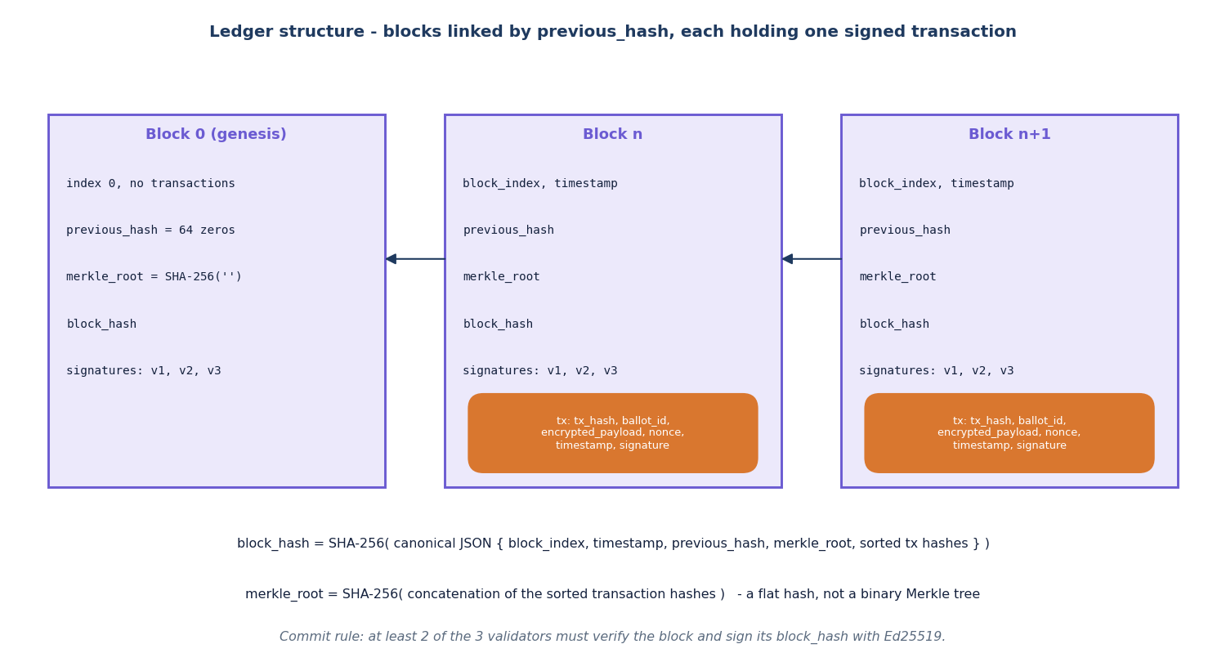
Figure 10: Structure of the ledger: blocks linked by previous_hash, each holding one signed transaction.

1.6.4 Security and audit modules
security/auth.py wraps Argon2id from argon2-cffi [23]. crypto.py provides SHA-256, canonical JSON, AES-256-GCM, Ed25519 and the Aadhaar salted hash. sessions.py keeps sessions in a dictionary in memory, each with a CSRF token. rate_limit.py is a sliding window of timestamps per key. audit.log_event writes one audit_logs row with actor, action, entity, details and client address; the API calls it for login success and failure, logout, verification success and failure, token issue, vote cast, vote rejected, election and candidate changes, integrity checks and tamper tests.

1.6.5 Benchmark module
run_benchmark creates synthetic voters (Argon2-hashed passwords, Verhoeff-valid Aadhaar numbers), runs a synchronous series and three batched series (batch sizes 10, 20 and 30), computes the mean, median, 95th percentile, minimum, maximum and standard deviation per series and the throughput, writes benchmark_results/*.json and stores a benchmark_runs row that the administrator's page displays. The batched series process each batch one vote after another in a single thread; they model the batch structure of the base paper but are not concurrent, and the results chapter treats them accordingly.

1.6.6 Front-end pages
Table 9: Pages of the React application (frontend/src/App.tsx)
Route | Role | Content
/ | public | Landing: live counts from /api/public/overview, how it works, elections on the ballot
/login | public | Sign-in with quick-fill demo accounts
/app/admin, /app/admin/elections, /app/admin/elections/:id, /app/admin/benchmarks | ADMIN | Dashboard with KPIs, validators and turnout chart; election list and creation; election detail with candidates and results; benchmark charts
/app/voter, /app/voter/:id/verify | VOTER | Election list; the three-step vote flow (verify, choose, receipt)
/app/auditor, /app/auditor/blocks/:index | AUDITOR | Chain integrity, validators, blocks, transactions, audit log; block detail with signatures
/app/results/:id | ADMIN, VOTER | Vote-share chart and ranked table of one election

A Protected wrapper redirects unauthenticated visitors to the login page and sends a signed-in user whose role does not match to the home page of their own role. This is a convenience only: every route is protected again on the server by the role dependencies, and the server is the only authority.

1.7 Algorithm Design
Two algorithms carry the design. The first is the casting algorithm, which decides whether a ballot is accepted; the second is the audit algorithm, which decides whether the recorded chain is still consistent. Their mathematics is given in Chapter 6; the flow charts show the control flow.
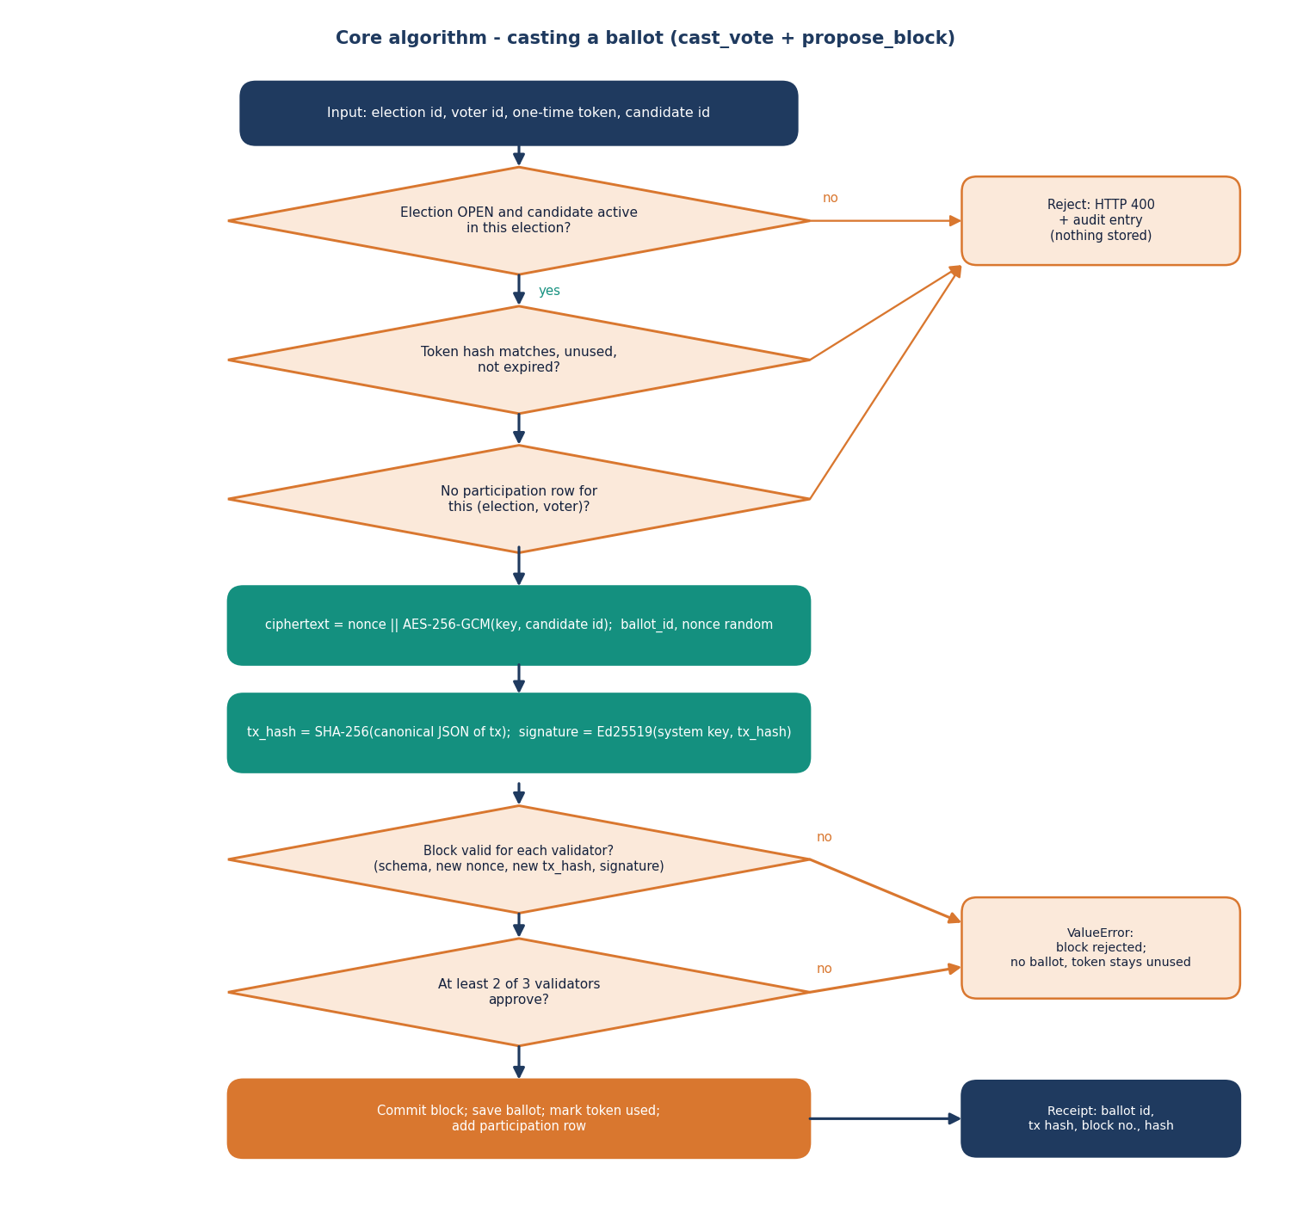
Figure 11: Flowchart of casting a ballot: checks, encryption, signing, quorum and commit.
The casting flow has three guard decisions before any cryptography is done. Failing one returns HTTP 400 and an audit entry and stores nothing. Two further decisions are taken by the validators: whether the block is valid for each of them, and whether at least two approve. If the quorum fails a ValueError is raised, the route answers with 400 and the token stays unused, so the voter may retry within the ten minutes.
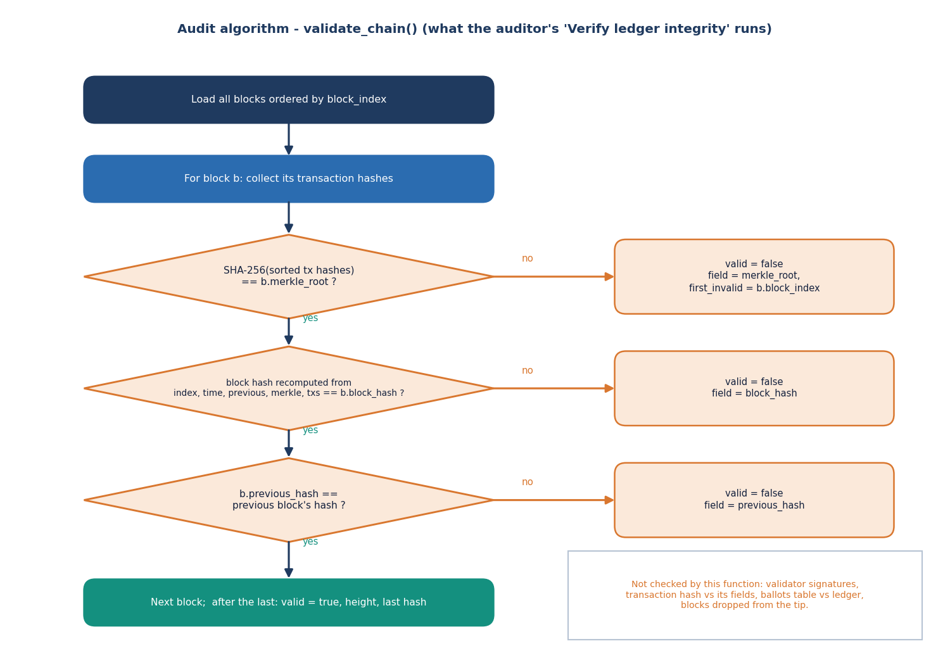
Figure 12: Flowchart of validate_chain, the function behind the auditor's integrity check.
The audit flow is deliberately simple: it uses only information in the ledger tables, so any holder of a copy can repeat it. The chart also shows its limits, which the tamper study of Chapter 8 measures: signatures and transaction hashes are not re-verified, and the ballots table is not compared with the ledger.

1.8 User-Interface Design
The interface is a single-page application with a dark and a light theme. The design follows five rules: one task per screen (the vote flow has three visible steps: verify identity, choose a candidate, receive the receipt); the state of the system is always visible (ledger height and health on the dashboards and on the landing page); destructive or irreversible actions ask for confirmation (the vote asks the voter to confirm the selection; closing an election is a separate button); every failure is shown as a toast with the server's message; and the notice "Demo verification environment - synthetic identities only" is shown wherever Aadhaar is entered.
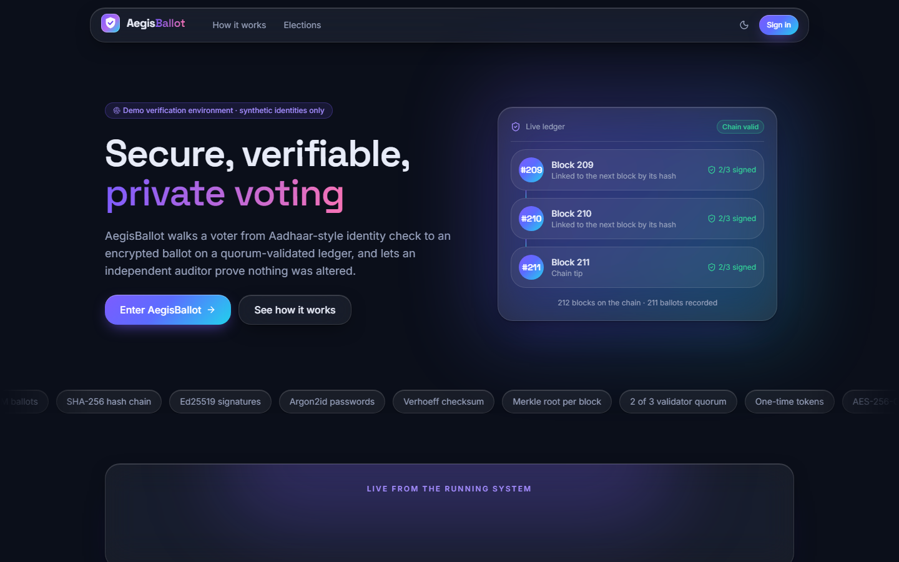  Figure 13: Landing page: live counts from the running ledger and the entry to the sign-in. | 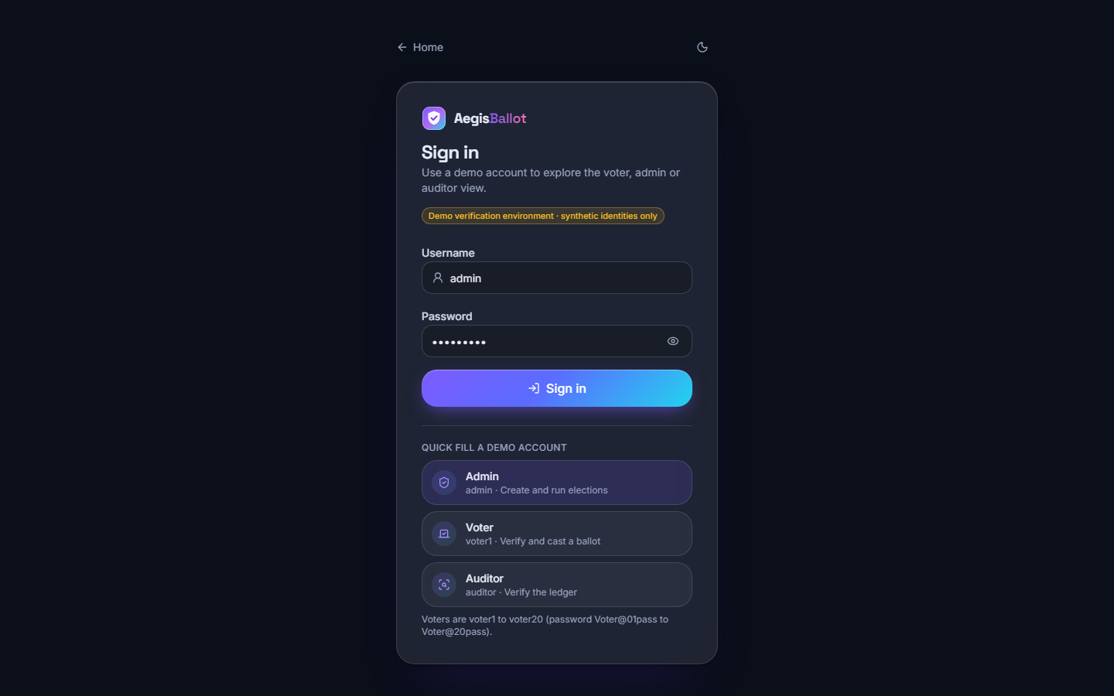  Figure 14: Sign-in page with quick-fill demo accounts for the three roles.

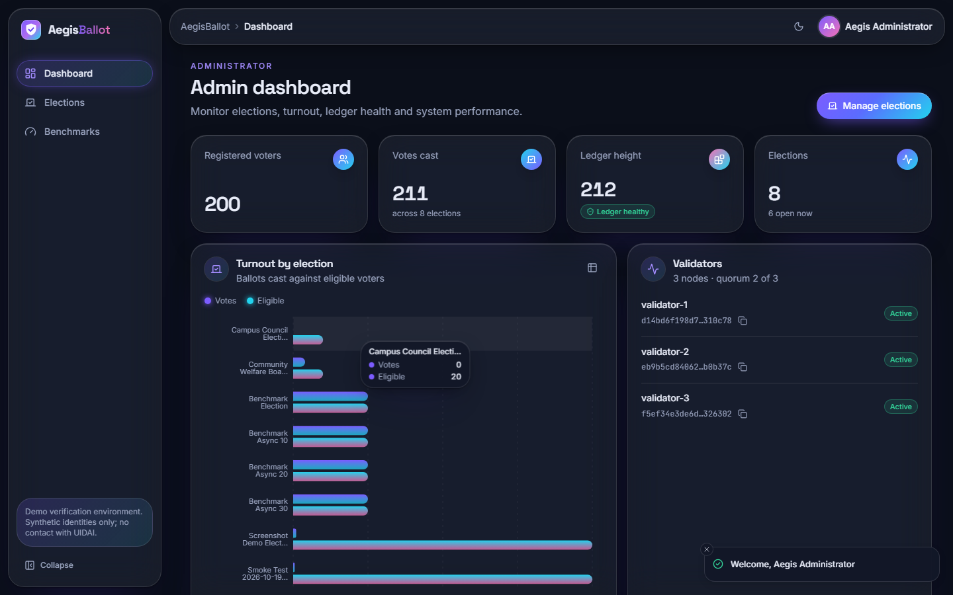  Figure 15: Administrator dashboard: voters, votes, ledger height, turnout per election and the three validators. | 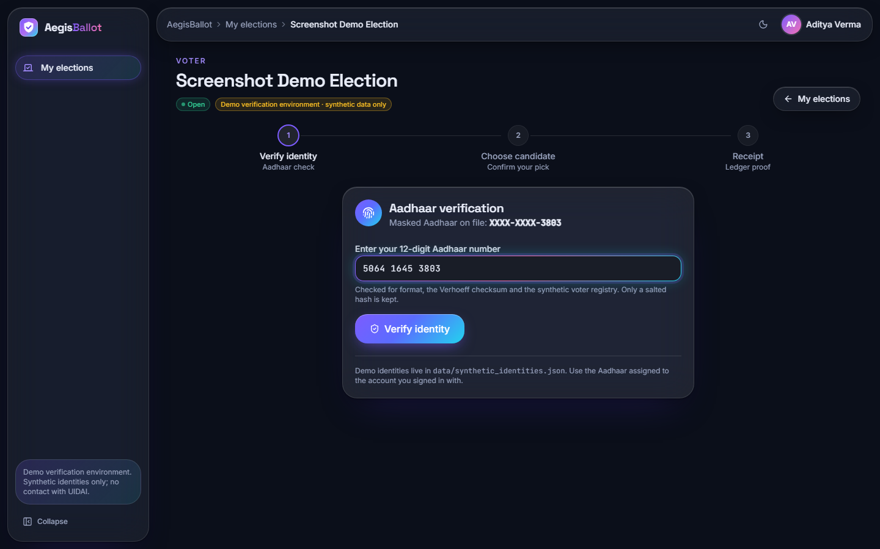  Figure 16: Voter flow, step 1: the masked Aadhaar of the account and the field for the 12-digit number.

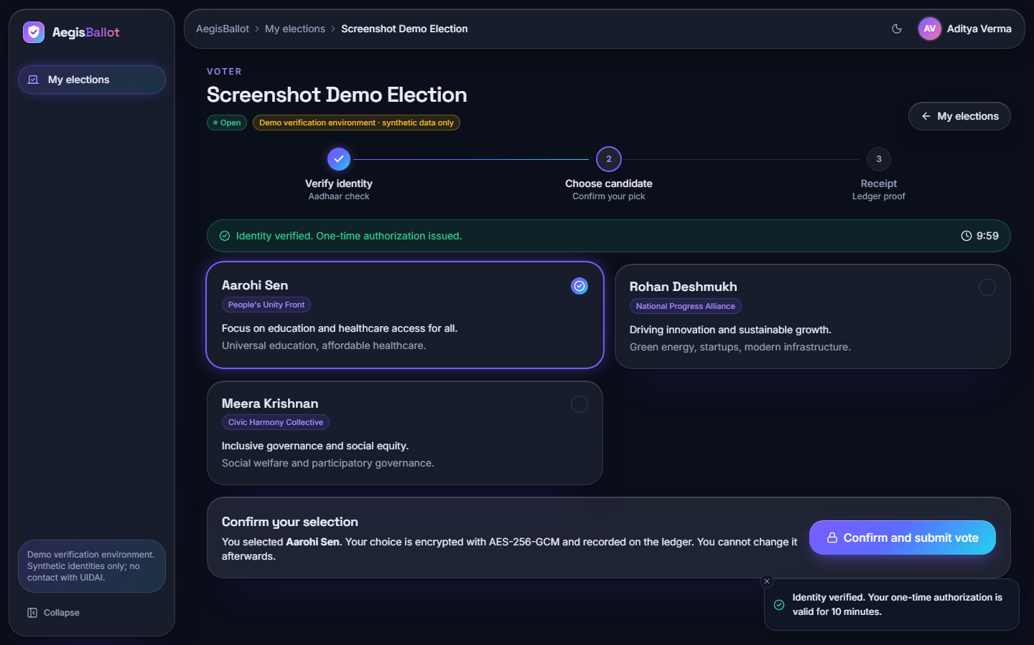  Figure 17: Voter flow, step 2: identity verified, ten-minute countdown, candidate cards and confirmation. | 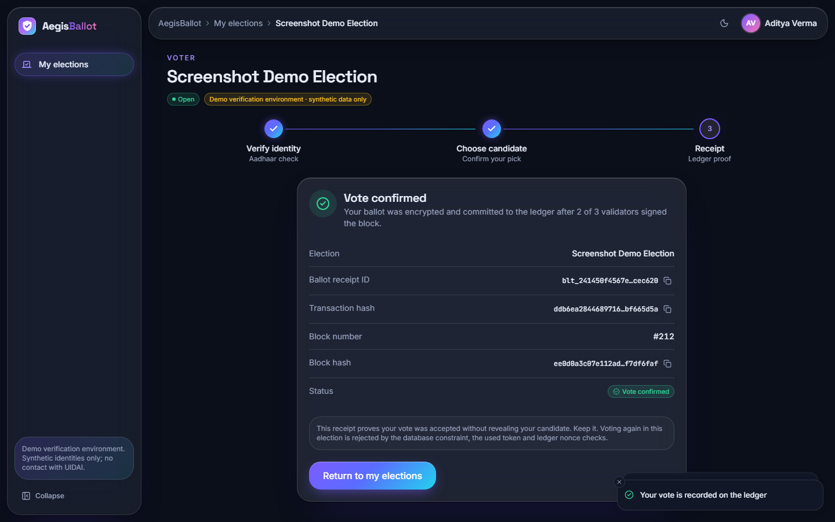  Figure 18: Voter flow, step 3: receipt with ballot id, transaction hash and block number.

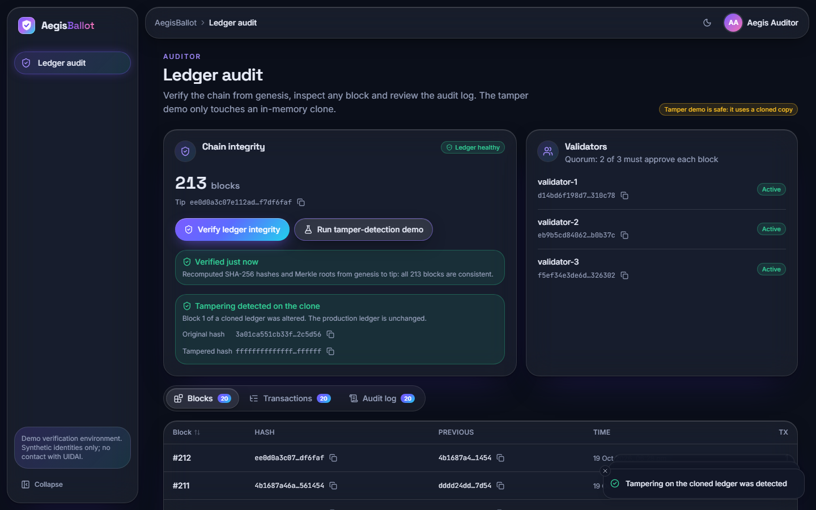  Figure 19: Auditor console: chain integrity, validators, blocks, transactions and the audit log. | 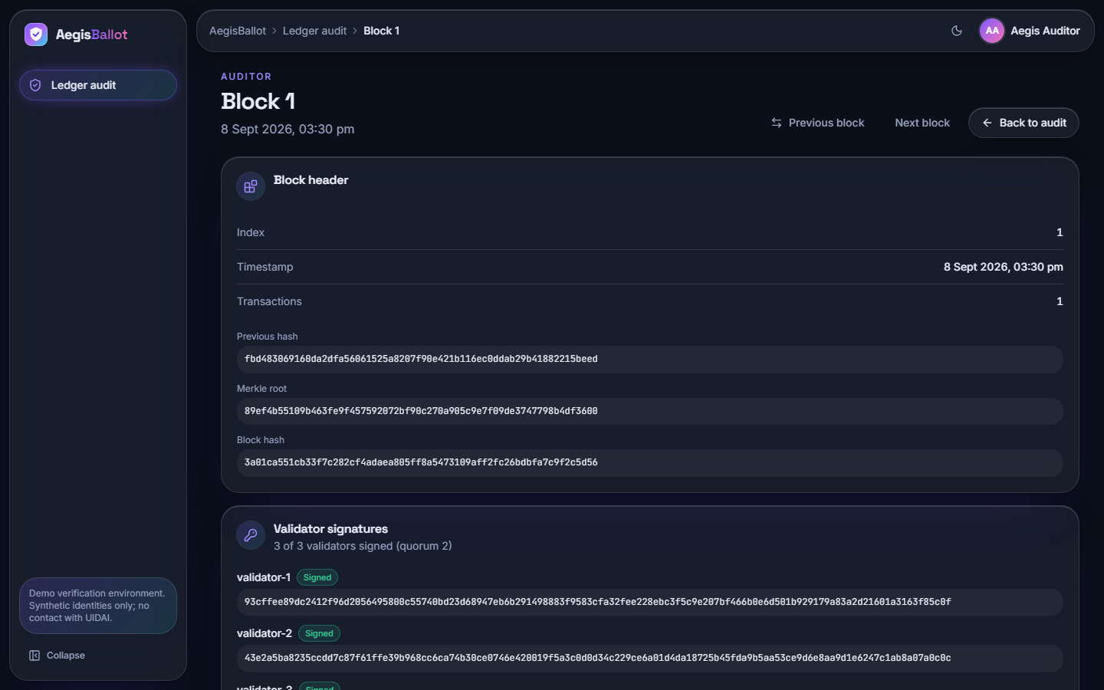  Figure 20: Block detail with previous hash, Merkle root, block hash and validator signatures.

Accessibility and layout choices are modest and honest: colour is never the only carrier of status (badges carry words), forms use labelled fields, and the layout was checked at 1440 by 900 pixels and at a 390 by 844 pixel phone width (the mobile administrator dashboard is shown in Appendix C). No formal accessibility audit or usability test with real voters was done.

1.9 Design Decisions and Their Reasons
Table 10: Principal design decisions
Decision | Alternatives considered | Reason
Local permissioned ledger, three in-process validators, quorum 2 of 3 | Public Ethereum chain as in the base paper; a real PBFT network | Runs on one laptop with no wallet or fees; Ethereum is quoted by the base paper at about 119.1 tx/s [1]; PBFT [18] needs a network of nodes that the project could not provide. The cost is that the trust is simulated
One transaction per block | Batching many votes in a block | Simple receipts (each voter gets a block number) and simple recovery; the cost is a longer chain and linear validation time
Aadhaar checked locally with Verhoeff and a salted-hash registry | Calling UIDAI; storing the number | UIDAI is not available to a student project; the Verhoeff check [25] catches mistyped numbers; storing only a hash avoids keeping the number
Token between identity and ballot | Sending the Aadhaar number with the ballot | The cast call carries a token, not an identity, and the token is stored only as a hash
Four overlapping one-vote rules | A single check in code | Unique constraints in the database hold even if the application logic is bypassed
AES-256-GCM for the choice | Plain candidate id; per-voter keys; homomorphic encryption | Authenticated encryption [21] hides choices from the ledger and the auditor view at low cost; a single key is the simplification
Ed25519 signatures | RSA; HMAC | Small, fast signatures [22]; 0.13 ms to sign in the micro-benchmark
Argon2id for passwords | bcrypt as in the batch abstract | Memory-hard, current guidance [24]; one verification costs about 83 ms, which dominates the HTTP latency
React single-page app over a JSON API | Server-rendered Jinja pages only | Role consoles with live data and charts; the Jinja pages remain as a fallback
SQLite | A client-server database | No installation; adequate for a demonstration; concurrent writers were not tested

2. IMPLEMENTATION

2.1 Application Architecture
The backend is a FastAPI application served by uvicorn on 127.0.0.1. On import, app/main.py creates the application, mounts the JSON router, calls init_db to create missing tables, and then calls init_validators and create_genesis_block so that the chain always has a block 0 and three validator keys. Requests are handled by synchronous route functions with a SQLAlchemy session per request (get_db). The session store, the rate limiter and the in-memory validator key table are module-level dictionaries, which keeps the code short and is the reason state is lost on restart (the database survives).
The frontend is a Vite project in frontend/. src/lib/api.ts creates the Axios client, stores the CSRF token returned by login and sends it on every mutating call; src/lib/queries.ts wraps each endpoint in a TanStack Query hook; src/lib/auth.tsx holds the user in a context and maps each role to its home route; src/pages holds one file per page; src/components/ui is a small component kit (cards, tables, badges, dialogs, toasts) built on Radix primitives and Tailwind CSS. Pages are loaded lazily, and the production build splits the chart, motion and Radix libraries into separate chunks. The Vite development and preview servers proxy /api to the backend, so the browser sees one origin and the session cookie needs no cross-origin settings.
Configuration comes from .env at the project root (BACKEND_PORT=8401 and FRONTEND_PORT=5401, read by run.bat and the Vite configuration) and from environment variables read in app/config.py (DATABASE_URL, SECRET_KEY, SESSION_SECRET, ELECTION_ENCRYPTION_KEY). The shipped defaults for SECRET_KEY and SESSION_SECRET are development strings in the source and must be replaced for any real use; the Aadhaar pepper is SECRET_KEY.

2.2 API Design
The JSON API has twenty-one routes in four groups, all under /api. Authentication is the aegis_session cookie; every route other than the three public ones resolves the session to a user, and every POST requires the X-CSRF-Token header to equal the CSRF token of the session. Errors are JSON of the form {"detail": "..."} with the status codes listed in the next section. The same functions back the legacy HTML pages, so the two interfaces cannot disagree.
Table 11: Routes of app/api_v1.py
Method | Path | Access | Purpose
POST | /api/auth/login | public | Verify credentials, create session and CSRF token, set cookie; 401 bad credentials, 429 throttled
POST | /api/auth/logout | signed in | Destroy the session, clear the cookie, write audit entry
GET | /api/auth/me | public | Current user and CSRF token, or user: null (200, so the console stays free of expected 401s)
GET | /api/public/overview | public | Elections, ledger validity and height, ballots cast, validator count (landing page)
GET | /api/admin/overview | ADMIN | Voters, votes, turnout, chain status, validators, latest benchmark, elections, five blocks, ten log rows
GET | /api/admin/elections | ADMIN | All elections with eligible, votes, turnout and candidate counts
POST | /api/admin/elections | ADMIN | Create an election (201); creates eligibility rows for all voters; 400 if end ≤ start
GET | /api/admin/elections/{eid} | ADMIN | Election, candidates, counts and, if CLOSED, the tally
POST | /api/admin/elections/{eid}/status | ADMIN | Set DRAFT, OPEN, PAUSED or CLOSED (400 otherwise)
POST | /api/admin/elections/{eid}/candidates | ADMIN | Add a candidate (201)
POST | /api/admin/candidates/{cid}/toggle | ADMIN | Activate or deactivate a candidate
GET | /api/admin/benchmarks | ADMIN | Last five benchmark runs with parsed details
GET | /api/elections/{eid}/results | signed in | Tally; ADMIN at any time, other roles only when CLOSED (else 404)
GET | /api/voter/elections | VOTER | Open, paused and closed elections with the voter's own participation
GET | /api/voter/elections/{eid} | VOTER | Election, masked Aadhaar, voted flag, ballot id
POST | /api/voter/elections/{eid}/verify | VOTER | Aadhaar checks; returns the one-time token (600 s) and candidates; 400, 403 or 429 on failure
POST | /api/voter/elections/{eid}/cast | VOTER | Candidate id and token; returns the receipt; 400 on any rejected check, 500 on an unexpected error
GET | /api/auditor/overview | AUDITOR | Chain status, validators, 20 blocks, 20 transactions, 20 log rows
POST | /api/auditor/verify | AUDITOR | Run validate_chain; audit entry integrity_check
POST | /api/auditor/tamper-test | AUDITOR | Run tamper_test_clone; audit entry tamper_test
GET | /api/auditor/blocks/{index} | AUDITOR | One block with parsed signatures and its transactions

2.3 Security Handling and Error Handling
Authentication state is held in an in-memory dictionary keyed by a 256-bit random token; the cookie is set with HttpOnly, SameSite=lax and Path=/. It has no Secure attribute because the application is served over plain HTTP on localhost, and the server never expires a session by time (only logout or a restart ends it). Passwords are never logged; a failed login writes the attempted username to the audit log, which means a mistyped password could be recorded if it is entered in the username field - a small privacy gap noted for the future.
Table 12: HTTP status codes used by the API
Status | Meaning in AegisBallot | Examples
200 / 201 | Success; 201 for created elections and candidates | login, cast, create election
400 | A business rule failed; nothing was stored | bad Aadhaar format or checksum, not in registry, already voted, invalid token, unknown candidate, election not open, end before start, invalid status
401 | No valid session | any protected route without cookie; wrong username or password
403 | Role not allowed, CSRF token missing or wrong, or the Aadhaar belongs to another voter | voter calling an admin route
404 | Resource missing, or results not yet published to a non-admin | unknown election; results of an OPEN election as a voter
422 | Request body failed Pydantic validation | empty username
429 | Rate limit reached | more than 10 logins or 15 verifications in 60 s from one address
500 | Unexpected failure while recording a vote | message: "Vote could not be recorded. Nothing was submitted; try again."

Failures that follow from business rules are raised as ValueError in the services and converted to HTTP 400 in the route; the route also writes the reason to the audit log (vote_rejected, aadhaar_verify_failed). If the ledger rejects a block, nothing is written, and the token remains valid until it expires. The React client converts every error into a toast with the server's message, and a failed request on the landing page shows a clear "Cannot reach the AegisBallot server" state.

2.4 Implementation Notes and Behaviour Found on Review
Writing the documents involved re-reading every route against the objectives of the batch. The review confirmed most behaviour and also produced a short list of facts that a reader of the report should know; they are repeated in the limitations chapter.
• Voting windows are not enforced. An election has start_time and end_time, and the administrator sets them, but cast_vote tests only that the status is OPEN. The status, changed by the administrator, is what opens and closes voting; the dates are information shown in the interface. The seeded closed election shows the effect: its end time was in the past while its status was still OPEN until the seed script closed it.
• There is no voter-registration route. Voters, their profiles and their synthetic Aadhaar numbers are created by app/seed.py or by the benchmark; the registry is therefore prepared offline, and objective 1 of the batch (registration and authentication) is met by authentication and verification against that registry, not by a self-service sign-up page.
• Eligibility is created with the election. POST /api/admin/elections inserts an eligibility row for every voter that exists at that moment; a voter added later is not eligible for earlier elections unless a row is added.
• One transaction per block. cast_vote always proposes a block of one transaction. The chain therefore grows by one block per vote, the receipt's block number identifies the vote, and validate_chain is linear in the number of votes.
• Validators approve in a fixed order and always agree. Because the three validators run the same checks on the same database inside one process, a block rejected by one is rejected by all; the quorum matters only if a validator key is missing, in which case the code records the string missing-priv as that validator's signature and still counts it as an approval.
• The transaction's public key travels inside the transaction. The validators verify the Ed25519 signature against the key supplied with the transaction; the system key is not pinned and the key is not stored in ledger_transactions. The check proves the transaction was not altered after signing, not that the signer was authorised.
• Times are naive UTC. Timestamps are produced by datetime.utcnow() and serialised without a zone, so the interface shows UTC.
• Concurrency was not tested. Each block takes the next index from the last block; two simultaneous votes could compute the same index, and the unique constraint on block_index would make one of them fail with a 500. The benchmark's "batched" series are sequential and do not exercise this.

2.5 Installation and Execution
The project needs Python 3.11 or 3.12 and Node.js 20 or newer; no database server, wallet or external credentials are required. On Windows, double-clicking run.bat creates .venv, installs requirements.txt, seeds the database (python -m app.seed), installs the front-end packages on the first run, checks that the ports are free, starts uvicorn on 8401 and Vite on 5401, and opens the browser. The manual method is five commands. Appendix B gives the full instructions, the demonstration accounts and troubleshooting.
python -m venv .venv
.venv\Scripts\activate
pip install -r requirements.txt
python -m app.seed
uvicorn app.main:app --host 127.0.0.1 --port 8401
:: second window
cd frontend
npm install
npm run dev

To reproduce the measurements: python -m pytest tests (17 tests; the fixture drops all tables, so set DATABASE_URL to a scratch file first), python -m app.benchmarks.run_benchmark --voters 1000, and python scripts/run_experiments.py <scratch-directory> for the growth, tamper and HTTP studies. A smoke test, python scripts/smoke_test.py, exercises the API and the main voting flow against running servers.

3. KEY CODE WALK-THROUGHS
This section reads the five functions that carry the system's behaviour. The listings are copied unchanged from the repository; line comments are the authors' own.

3.1 Identity verification: DemoAadhaarProvider.verify
def verify(self, aadhaar_number: str, db: Session) -> dict:
# checks
clean = aadhaar_number.replace(" ", "").replace("-", "")
if len(clean) != 12 or not clean.isdigit():
return {"success": False, "reason": "Invalid Aadhaar format: must be 12 digits"}
if not validate_verhoeff(clean):
return {"success": False, "reason": "Invalid Aadhaar checksum (Verhoeff)"}
# check existence
h = hash_aadhaar(clean)
profile = db.query(VoterProfile).filter(VoterProfile.aadhaar_hash == h).first()
if not profile:
return {"success": False, "reason": "Aadhaar not found in voter registry"}
user = db.query(User).filter(User.id == profile.user_id).first()
return {
"success": True,
"profile": profile,
"user": user,
"masked": profile.aadhaar_masked,
"reason": "Verified via DemoAadhaarProvider (local synthetic registry)"
}

The function strips spaces and hyphens, insists on exactly twelve digits, runs the Verhoeff checksum, hashes the number with a salt and the server pepper and looks the hash up in voter_profiles. It returns a dictionary rather than raising, so the API route can turn each failure reason into the HTTP 400 that was exercised in the matrix. The class implements IdentityVerificationProvider, an abstract interface with the same signature, which is the seam where a real adapter would be plugged in. Note what is not here: the function does not know which voter is signed in; the route compares result['user'].id with the session user and returns 403 on a mismatch.

3.2 Token issue: issue_authorization
def issue_authorization(db: Session, election_id: int, voter_user_id: int) -> str:
# check eligibility
elig = db.query(VoterEligibility).filter(VoterEligibility.election_id==election_id, VoterEligibility.voter_user_id==voter_user_id).first()
if not elig or not elig.is_eligible:
raise ValueError("Voter not eligible for this election")
# check already voted
part = db.query(VoterParticipation).filter(VoterParticipation.election_id==election_id, VoterParticipation.voter_user_id==voter_user_id).first()
if part:
raise ValueError("Voter has already voted in this election")
# check existing auth not used
existing = db.query(VotingAuthorization).filter(VotingAuthorization.election_id==election_id, VotingAuthorization.voter_user_id==voter_user_id).first()
if existing and not existing.is_used:
# reuse if not expired
if existing.expires_at > datetime.utcnow():
raise ValueError("Authorization already issued and pending")
else:
db.delete(existing)
db.commit()
token = secrets.token_urlsafe(32)
th = hash_token(token)
auth = VotingAuthorization(
election_id=election_id,
voter_user_id=voter_user_id,
token_hash=th,
is_used=False,
expires_at=datetime.utcnow()+timedelta(minutes=10)
)
db.add(auth)
db.commit()
return token

Three guards run before a token exists: the voter must have an eligibility row marked eligible, must have no participation row, and must not hold a still-valid unused authorisation. The token is secrets.token_urlsafe(32), 256 bits of randomness; only its SHA-256 hash is stored, so a database leak does not reveal usable tokens. The expiry is ten minutes, and a unique constraint on (election, voter) means a second token cannot be inserted while the first row exists.

3.3 Casting: cast_vote
# verify auth
auth = verify_authorization(db, election_id, voter_user_id, token)
# check participation constraint
exists = db.query(VoterParticipation).filter(VoterParticipation.election_id==election_id, VoterParticipation.voter_user_id==voter_user_id).first()
if exists:
raise ValueError("Duplicate vote detected")
# encrypt ballot
ballot_id = generate_ballot_id()
nonce = generate_nonce()
plaintext = str(candidate_id)
encrypted = encrypt_ballot(plaintext)
# transaction hash
tx_payload = {
"election_id": election_id,
"ballot_id": ballot_id,
"encrypted_payload": encrypted,
"nonce": nonce,
"timestamp": datetime.utcnow().isoformat(),
}
tx_hash = sha256_hex(canonical_serialize(tx_payload))
# sign with system key
priv, pub = get_system_keypair()
sig = sign_message(priv, tx_hash.encode())
tx = {
**tx_payload,
"tx_hash": tx_hash,
"signature": sig,
"pubkey": pub
}
# propose block (single tx per block for simplicity, quorum)
block = propose_block(db, [tx])

After the election, candidate and token checks, the function generates a random ballot id and nonce, encrypts the candidate id with AES-256-GCM, builds the transaction from five fields, hashes its canonical JSON, signs the hash with the system Ed25519 key and calls propose_block. Only when the block is committed does it write the ballot row, mark the token used and add the participation row, all in one commit; if the ledger raises, nothing was stored and the token is still usable. The block commit inside propose_block and the ballot commit here are two separate commits, so a crash between them would leave a block without a ballot. In the stage measurements the encryption, hashing and signing together take 0.53 ms, which is why the cost of a vote is dominated by database work and block proposal.

3.4 Committing: propose_block
ts = datetime.utcnow()
ts_iso = ts.isoformat()
prev_hash = last_block.block_hash
tx_hashes = [t["tx_hash"] for t in transactions]
merkle = compute_merkle_root(tx_hashes)
block_hash = compute_block_hash(next_index, ts_iso, prev_hash, merkle, tx_hashes)
...
if valid:
# sign block hash
priv = privates.get(nid)
if priv:
sig = sign_message(priv, block_hash.encode())
approvals[nid] = sig
else:
approvals[nid] = "missing-priv"
else:
rejections.append((nid, reason))
# quorum 2/3
if len(approvals) < 2:
raise ValueError(f"Block rejected by validators: {rejections}")
# commit block
block = LedgerBlock(
block_index=next_index,
timestamp=ts,
previous_hash=prev_hash,
merkle_root=merkle,
block_hash=block_hash,
validator_signatures=json.dumps(approvals),
transaction_count=len(transactions)
)
db.add(block)

The block hash is computed first, from the next index, the timestamp, the previous block's hash, the flat Merkle root and the sorted transaction hashes. In the elided part each of the three validators re-checks the schema, the uniqueness of the nonce and of the transaction hash and, when a public key is present, the transaction signature. A validator that finds no fault signs the block hash with its Ed25519 key. If fewer than two approve, a ValueError is raised and nothing is committed; otherwise the block is stored with the approvals as JSON. Because the validators are three loop iterations in one process, the quorum rule is correctly implemented but is not an agreement between separate machines.

3.5 Auditing: validate_chain
def validate_chain(db: Session) -> dict:
blocks = db.query(LedgerBlock).order_by(LedgerBlock.block_index.asc()).all()
if not blocks:
return {"valid": False, "reason": "empty chain"}
for i, b in enumerate(blocks):
# recompute merkle and hash
txs = db.query(LedgerTransaction).filter(LedgerTransaction.block_index == b.block_index).all()
tx_hashes = [t.tx_hash for t in txs]
expected_merkle = compute_merkle_root(tx_hashes)
if b.merkle_root != expected_merkle:
return {"valid": False, "first_invalid": b.block_index, "expected": expected_merkle, "actual": b.merkle_root, "field": "merkle_root"}
ts_iso = b.timestamp.isoformat() if isinstance(b.timestamp, datetime) else str(b.timestamp)
# need to ensure same format as creation; we stored iso from datetime; recompute using same iso
# To avoid mismatch, we recompute using stored timestamp iso
expected_hash = compute_block_hash(b.block_index, ts_iso, b.previous_hash, b.merkle_root, tx_hashes)
if b.block_hash != expected_hash:
return {"valid": False, "first_invalid": b.block_index, "expected": expected_hash, "actual": b.block_hash, "field": "block_hash"}
if i > 0:
prev = blocks[i-1]
if b.previous_hash != prev.block_hash:
return {"valid": False, "first_invalid": b.block_index, "expected": prev.block_hash, "actual": b.previous_hash, "field": "previous_hash"}
return {"valid": True, "height": len(blocks), "last_hash": blocks[-1].block_hash if blocks else None}

For every block the function recomputes the Merkle root from the stored transactions, recomputes the block hash from the stored fields, and compares the previous hash with the preceding block. The first mismatch is returned with the field name and the block index, which is what the auditor page displays. The listing also shows the limits found in the tamper study: nothing here reads validator_signatures, recomputes a tx_hash from the transaction fields or looks at the ballots table, and a chain with its newest blocks removed is still internally consistent.

4. IMPLEMENTATION DECISIONS AND THEIR REASONS
The table lists the main implementation decisions, the reason for each and the alternative that was not taken. Several decisions were made for the sake of a runnable, locally testable prototype and are revisited in Chapter 10.
Table 13: Implementation decisions and their reasons
Decision | Reason | Alternative not taken
Local permissioned ledger in Python instead of Ethereum | Runs on one PC without a node, gas or test network; keeps the demonstration reproducible; the batch asks for hashing and immutability, not a public chain | Geth or Ganache with Solidity contracts, as in the base paper
Three validators with quorum 2 of 3 | Shows the commit rule and signed approvals at small cost; mirrors the idea of permissioned consensus [18, 17] | A single signer, or a real network of nodes
One transaction per block | Gives every vote its own block number for the receipt and simplifies ordering | Batching several ballots per block, which would raise throughput
SHA-256 hash chain with canonical JSON | Deterministic bytes make hashes reproducible by an auditor [20] | Pickle or ad-hoc string concatenation
Flat hash instead of a Merkle tree | Simpler code for one-transaction blocks | Binary Merkle tree with inclusion proofs [19]
AES-256-GCM for the choice, single server key | Authenticated encryption with a random 12-byte nonce [21]; one key keeps tallying simple | Per-election keys, threshold or homomorphic encryption
Ed25519 signatures | Fast (0.13 ms to sign, 0.18 ms to verify) and small [22] | RSA or ECDSA
Argon2id for passwords | Memory-hard; about 83 ms per verification on this PC [23] | bcrypt (named in the batch abstract)
Verhoeff checksum before the registry lookup | Rejects mistyped numbers cheaply and without a database query [25] | Format check only
Salted and peppered hash of the Aadhaar number | The registry never stores the plain number; the display uses a masked form | Plain text or an unsalted hash
Single-use token with a hashed copy and ten-minute expiry | Separates identity checking from ballot casting and defeats replay | Reusing the session as the voting credential
Unique constraints in the database | The database itself refuses a second participation or token row, even if application code is bypassed | Application-level checks only
Server-side sessions, CSRF header and per-IP rate limit | Simple and testable for a single process [28] | JWT stored in the browser; Redis-backed limits
FastAPI JSON layer beside the original Jinja pages | The React front end needed JSON; the existing routes and tests stayed untouched | Rewriting the HTML routes
SQLite | Zero configuration for a local demonstration | PostgreSQL, which would allow real concurrency

Two decisions deserve a closer word. Counting the tally from the ballots table rather than from the ledger was convenient, but it is the reason why edits to that table are not detected by the ledger check; the tamper study turned a design shortcut into a measured finding. Storing the voter id beside the ballot id in the participation table made the one-vote constraint trivial to enforce, at the price of weaker unlinkability.
Several decisions favour testability over strength. Keeping validators in one process made the quorum code easy to unit-test (a tampered block, a duplicate nonce and a bad previous hash all have tests) and made the benchmark reproducible; it also means the quorum protects nothing against the host. Writing the JSON layer beside the HTML routes rather than replacing them kept the existing test suite valid while the new interface was built. In each case the cheaper choice was taken knowingly and its cost is recorded in the limitations and the future scope.

